Sir Syed University of Engineering & Technology (SSUET)

Department of Software Engineering

# Cyber Security Program

# 

# PROJECT REPORT

## PROJECT TITLE

## DESIGN AND SIMULATION OF HIERARHICAL ENTERPRISE NETWORK



***MUHAMMAD HASNAIN***

# TABLE OF CONTENTS

|  |  |  |
| --- | --- | --- |
| S.NO. | TOPICS | Page No. |
| 1 | INTRODUCTION | 4 |
| 2 | NETWORK TOPOLOGY OVERVIEW | 5 - 6 |
| 3 | DESIGN CHOICES | 7 - 9 |
| 4 | COMPLETE NETWORK CONFIGURATION | 10 - 23 |
| 5 | PING RESULTS | 24 |
| 6 | CONCLUSION | 25 |

# INTRODUCTION

This report details the design, configuration, and troubleshooting of a comprehensive network topology built using Cisco Packet Tracer. The project involves multiple routers and switches configured to ensure full connectivity across various segments and end devices. The core objective was to establish a functional, routable network utilizing Class A IP addressing and **OSPF (Open Shortest Path First)** as the dynamic routing protocol.

# Network Topology Overview

The network topology consists of a central distribution layer with two core routers connected via a switch, radiating out to multiple access and distribution routers, and finally connecting to various end-user PCs.

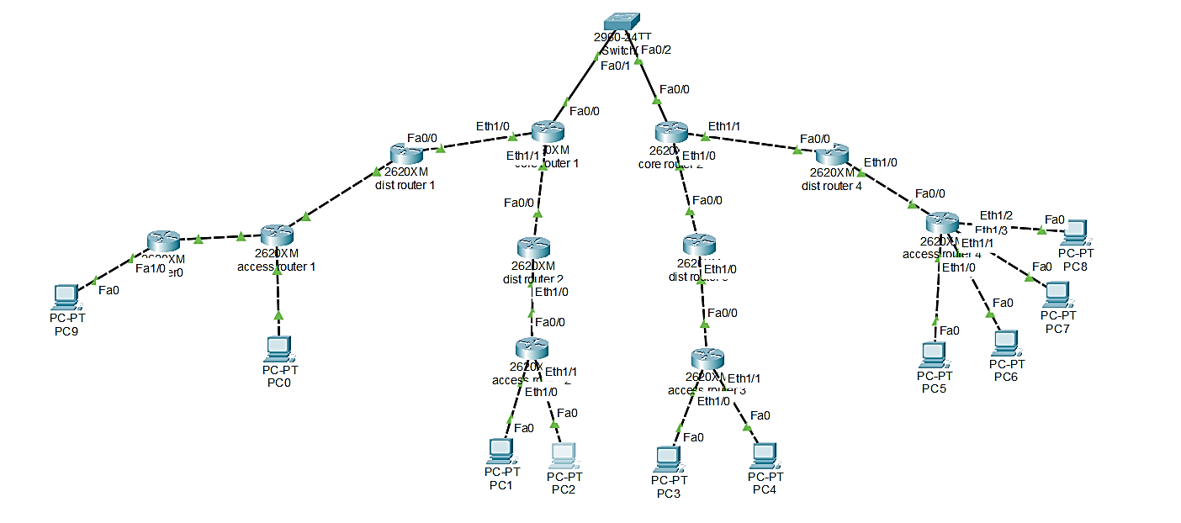

The key components and their roles are as follows:

* **Router0 (Edge Router):** The leftmost router, serving as an entry point to the main network, connecting to PC9 and access router 1.
* **access router 1 (2620XM):** Connects Router0 and PC0 to dist router 1.
* **dist router 1 (2620XM):** Connects access router 1 to core router 1.
* **core router 1 (2620XM):** A central distribution layer router, connected to dist router 1, dist router 2, and Switch0.
* **Switch0 (2960-24TT):** Connects core router 1 and core router 2 in the central distribution layer.
* **core router 2 (2620XM):** The other central distribution layer router, connected to Switch0, dist router 3, and dist router 4.
* **dist router 2 (2620XM):** Connects core router 1 to access router 2.
* **access router 2 (2620XM):** Connects dist router 2 to PC1 and PC2.
* **dist router 3 (2620XM):** Connects core router 2 to access router 3.
* **access router 3 (2620XM):** Connects dist router 3 to PC3 and PC4.
* **dist router 4 (2620XM):** Connects core router 2 to access router 4.
* **access router 4 (2620XM):** Connects dist router 4 to PC5, PC6, PC7, and PC8.
* **End Devices (PC-PT PCs):** Multiple PCs connected to various access layer routers, representing client workstations.

## Design Choices

**3.1 IP Addressing Scheme**

A Class A IP addressing scheme was implemented using /30 (255.255.255.252) subnets for point-to-point router links and /24 (255.255.255.0) subnets for LAN segments. This provides efficient and scalable address allocation for the network, conserving IP addresses where appropriate.

**Summary of Segments and Assigned IPs:**

|  |  |  |  |  |
| --- | --- | --- | --- | --- |
| **Segment ID** | **Connection / Description** | **Network ID** | **Router/Interface IP** | **End Device IP** |
| 1 | Router0 LAN - PC9 | 10.0.20.0/24 | Router0 (Fa0/1): 10.0.20.1 | PC9: 10.0.20.10 |
| 2 | Router0 Fa0/0 - access router 1 Fa0/0 | 10.0.1.0/30 | Router0 (Fa0/0): 10.0.1.1 acc. router 1 (Fa0/0): 10.0.1.2 |  |
| 3 | access router 1 Fa0/1 - PC0 | 10.0.2.0/24 | acc. router 1 (Fa0/1): 10.0.2.1 | PC0: 10.0.2.10 |
| 4 | access router 1 Fa0/2 - dist router 1 Fa0/0 | 10.0.3.0/30 | acc. router 1 (Fa0/2): 10.0.3.1 dist router 1 (Fa0/0): 10.0.3.2 |  |
| 5 | dist router 1 Fa0/1 - core router 1 Fa0/0 | 10.0.4.0/30 | dist router 1 (Fa0/1): 10.0.4.1 core router 1 (Fa0/0): 10.0.4.2 |  |
| 6 | core router 1 Fa0/1 - dist router 2 Fa0/0 | 10.0.5.0/30 | core router 1 (Fa0/1): 10.0.5.1 dist router 2 (Fa0/0): 10.0.5.2 |  |
| 7 | dist router 2 Fa0/1 - access router 2 Fa0/0 | 10.0.6.0/30 | dist router 2 (Fa0/1): 10.0.6.1 acc. router 2 (Fa0/0): 10.0.6.2 |  |
| 8 | access router 2 Fa0/1 - PC1 | 10.0.7.0/24 | acc. router 2 (Fa0/1): 10.0.7.1 | PC1: 10.0.7.10 |
| 9 | access router 2 Fa0/2 - PC2 | 10.0.8.0/24 | acc. router 2 (Fa0/2): 10.0.8.1 | PC2: 10.0.8.10 |
| 10 | core router 1 Fa0/2 - Switch0 - core router 2 Fa0/0 | 10.0.9.0/30 | core router 1 (Fa0/2): 10.0.9.1 core router 2 (Fa0/0): 10.0.9.2 | Switch0 (VLAN1): 10.0.9.3 |
| 11 | core router 2 Fa0/1 - dist router 3 Fa0/0 | 10.0.10.0/30 | core router 2 (Fa0/1): 10.0.10.1 dist router 3 (Fa0/0): 10.0.10.2 |  |
| 12 | dist router 3 Fa0/1 - access router 3 Fa0/0 | 10.0.11.0/30 | dist router 3 (Fa0/1): 10.0.11.1 acc. router 3 (Fa0/0): 10.0.11.2 |  |
| 13 | access router 3 Fa0/1 - PC3 | 10.0.12.0/24 | acc. router 3 (Fa0/1): 10.0.12.1 | PC3: 10.0.12.10 |
| 14 | access router 3 Fa0/2 - PC4 | 10.0.13.0/24 | acc. router 3 (Fa0/2): 10.0.13.1 | PC4: 10.0.13.10 |
| 15 | core router 2 Fa0/2 - dist router 4 Fa0/0 | 10.0.14.0/30 | core router 2 (Fa0/2): 10.0.14.1 dist router 4 (Fa0/0): 10.0.14.2 |  |
| 16 | dist router 4 Fa0/1 - access router 4 Fa0/0 | 10.0.15.0/30 | dist router 4 (Fa0/1): 10.0.15.1 acc. router 4 (Fa0/0): 10.0.15.2 |  |
| 17 | access router 4 Fa0/1 - PC5 | 10.0.16.0/24 | acc. router 4 (Fa0/1): 10.0.16.1 | PC5: 10.0.16.10 |
| 18 | access router 4 Fa0/2 - PC6 | 10.0.17.0/24 | acc. router 4 (Fa0/2): 10.0.17.1 | PC6: 10.0.17.10 |
| 19 | access router 4 Fa0/3 - PC7 | 10.0.18.0/24 | acc. router 4 (Fa0/3): 10.0.18.1 | PC7: 10.0.18.10 |
| 20 | access router 4 Fa0/4 - PC8 | 10.0.19.0/24 | acc. router 4 (Fa0/4): 10.0.19.1 | PC8: 10.0.19.10 |

**3.2 Routing Protocol: OSPF**

OSPF (Open Shortest Path First) was chosen as the dynamic routing protocol. OSPF is a link-state routing protocol, which means it maintains a complete topological map of the network. This provides faster convergence and better scalability compared to distance-vector protocols like RIP, making it ideal for this hierarchical design. All routers are configured within a single OSPF Area 0, simplifying the initial deployment.

**3.3 Interface Types**

The network predominantly uses Fast Ethernet interfaces (Fa). In some cases, standard Ethernet interfaces (Et) are present. The configuration commands for both interface types are identical, only requiring the correct interface name (e.g., FastEthernet0/0 vs. Ethernet0/0). Proper physical connection to the designated interface is critical for connectivity.

# Complete Network Configuration

Below are the detailed configurations for each device in the topology, reflecting the OSPF routing protocol and /30 and /24 subnetting.

**4.1. Router0 (2620XM)**

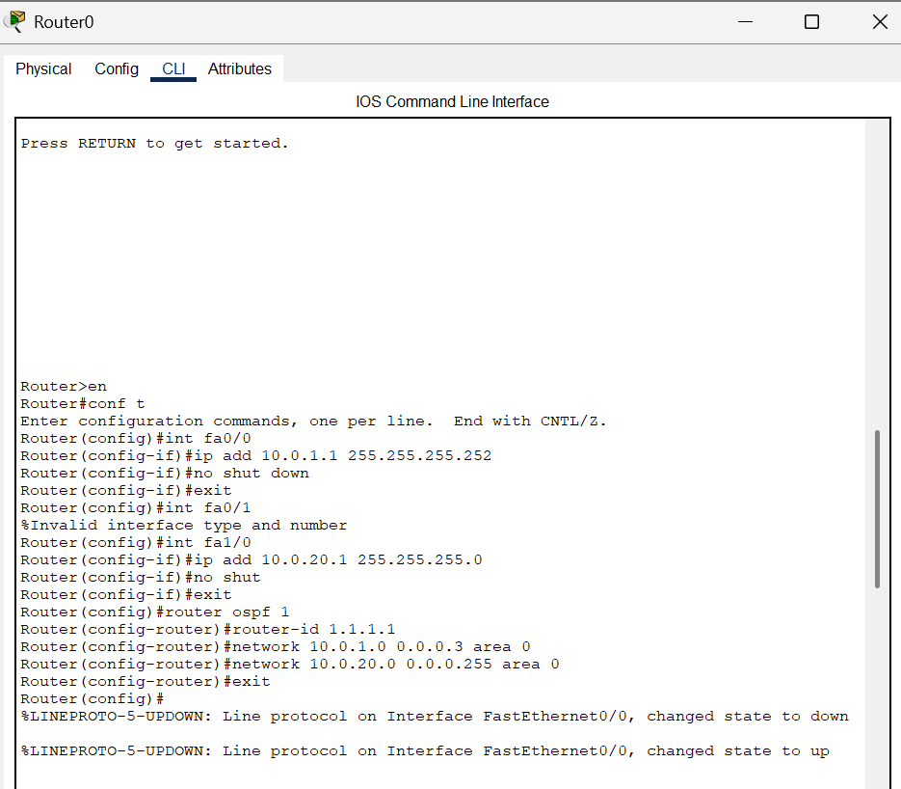

**4.2. PC-PT PC9**

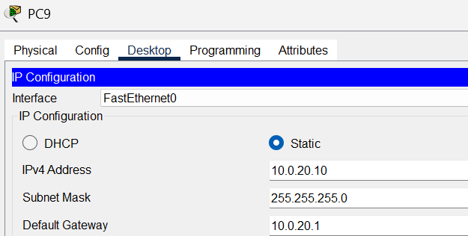

**4.3. access router 1 (2620XM)**

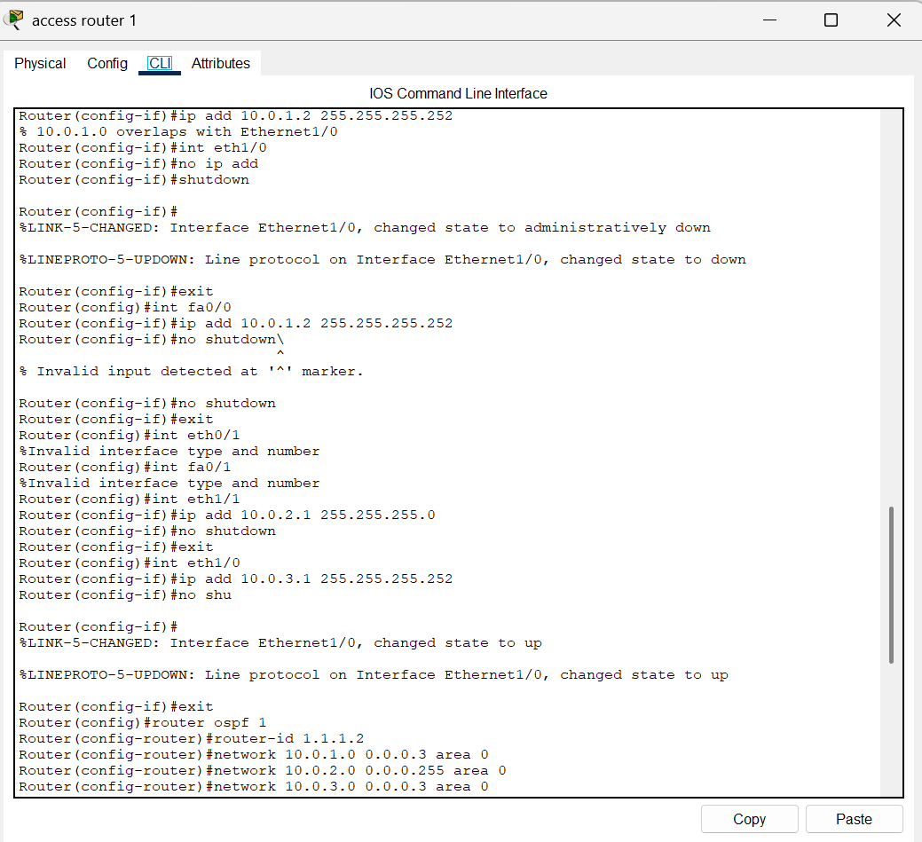

**4.4. PC-PT PC0**

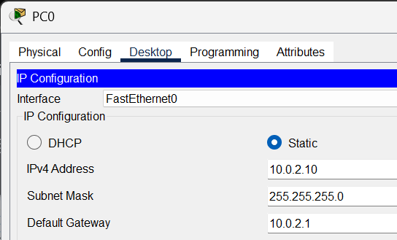

**4.5. dist router 1 (2620XM)**

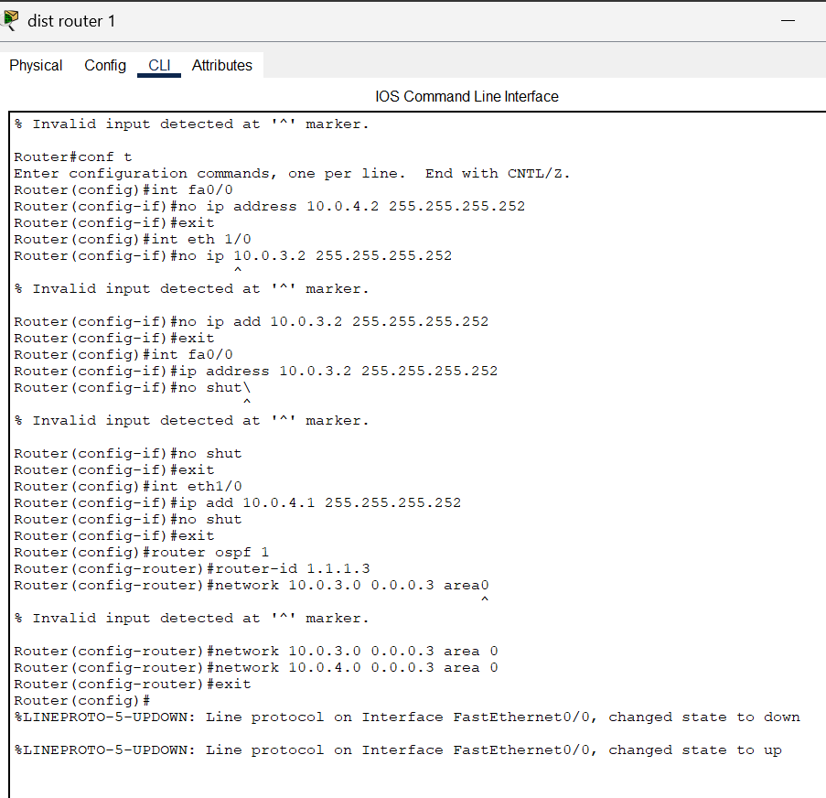

**4.6. core router 1 (2620XM)**

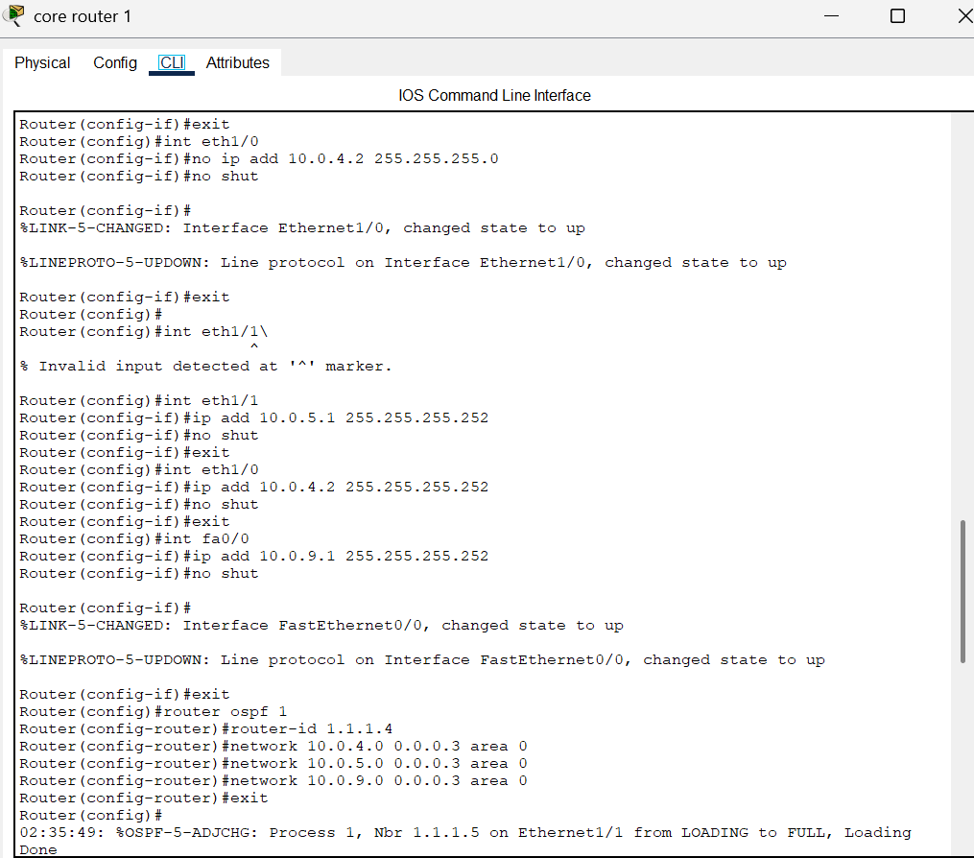

**4.7. dist router 2 (2620XM)**

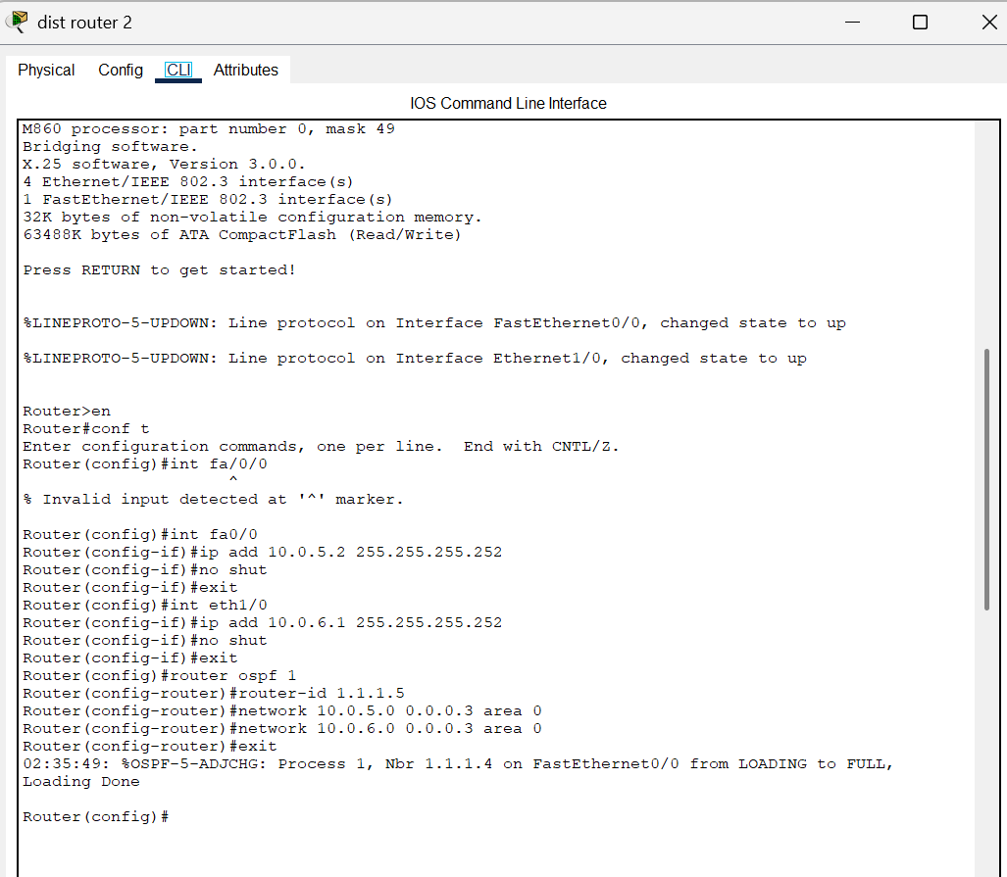

**4.8. access router 2 (2620XM)**

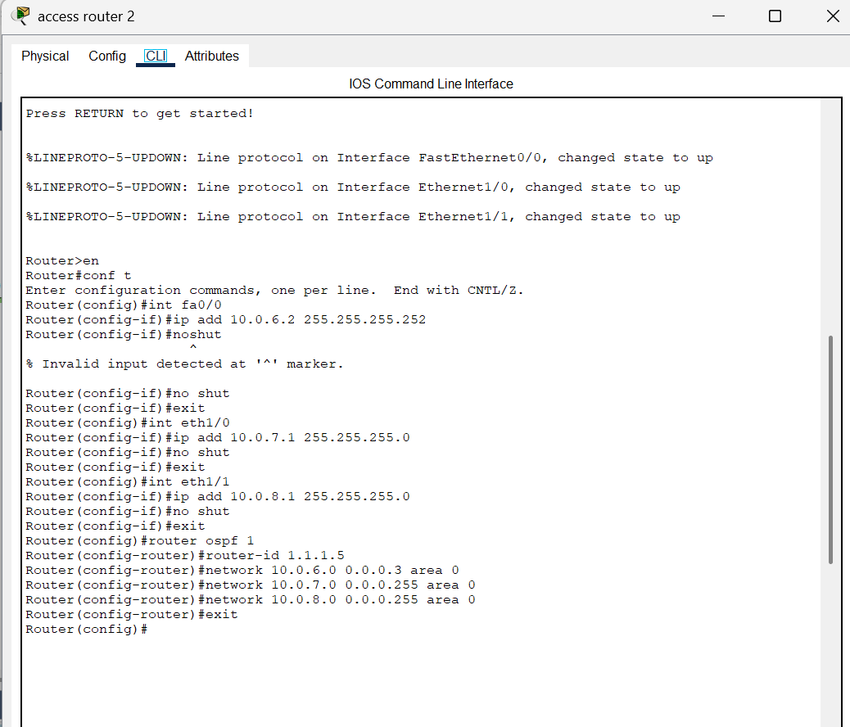

**4.9. PC-PT PC1**

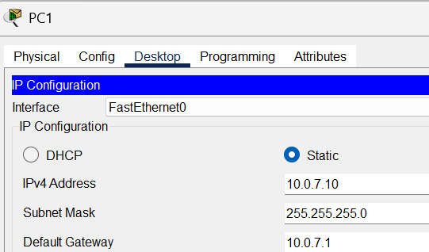

**4.10. PC-PT PC2**

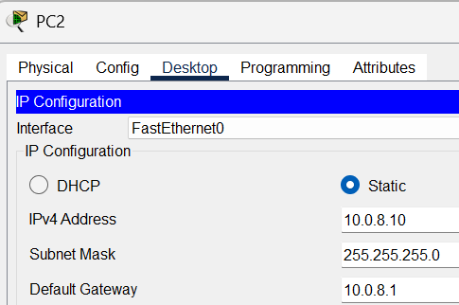

**4.11. Switch0 (2960-24TT)**

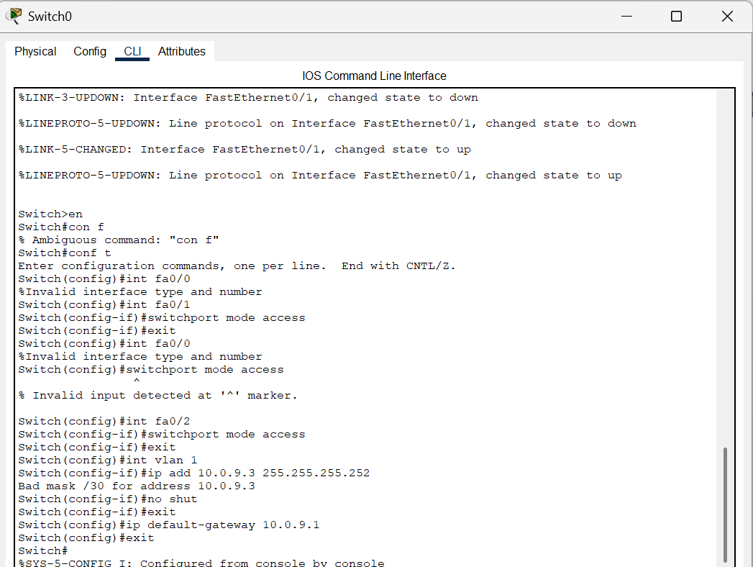

**4.12. core router 2 (2620XM)**

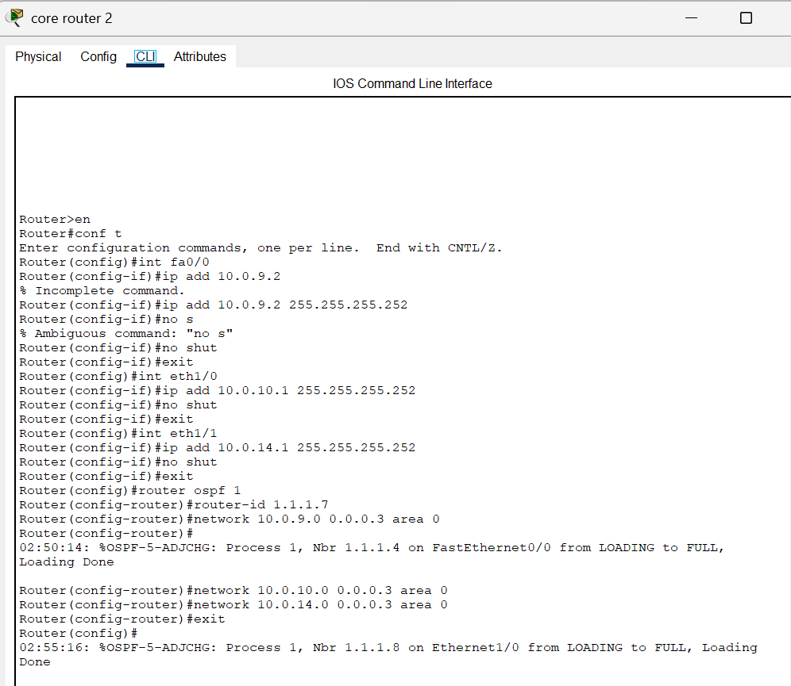

**4.13. dist router 3 (2620XM)**

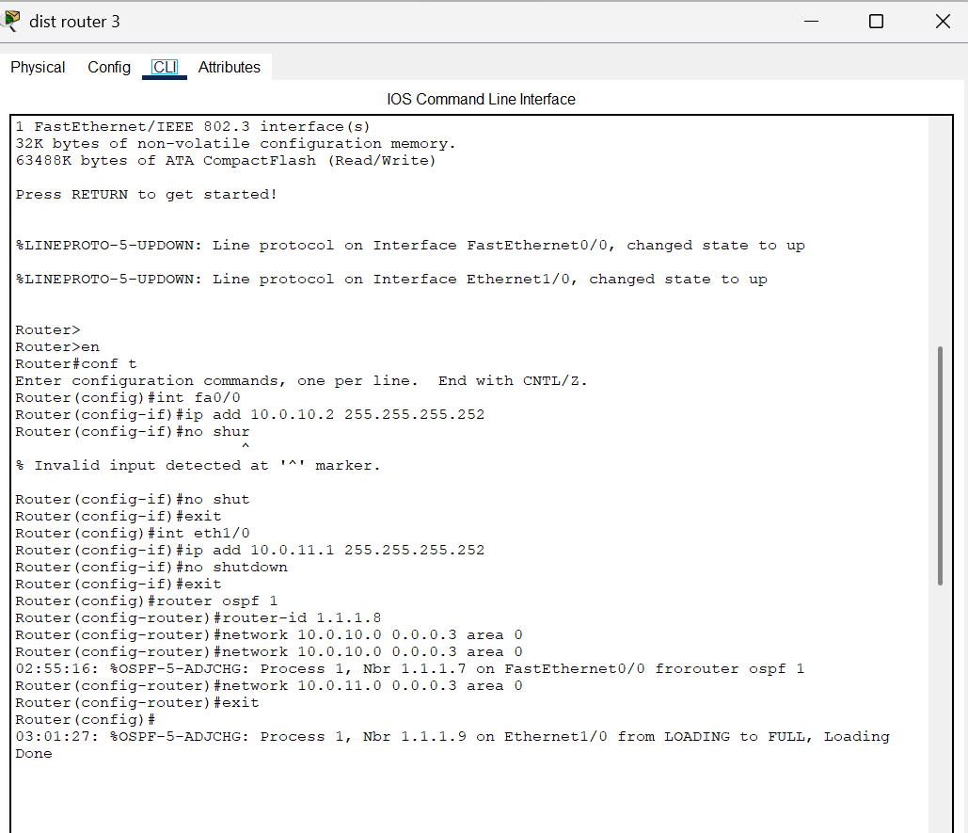

**4.14. access router 3 (2620XM)**

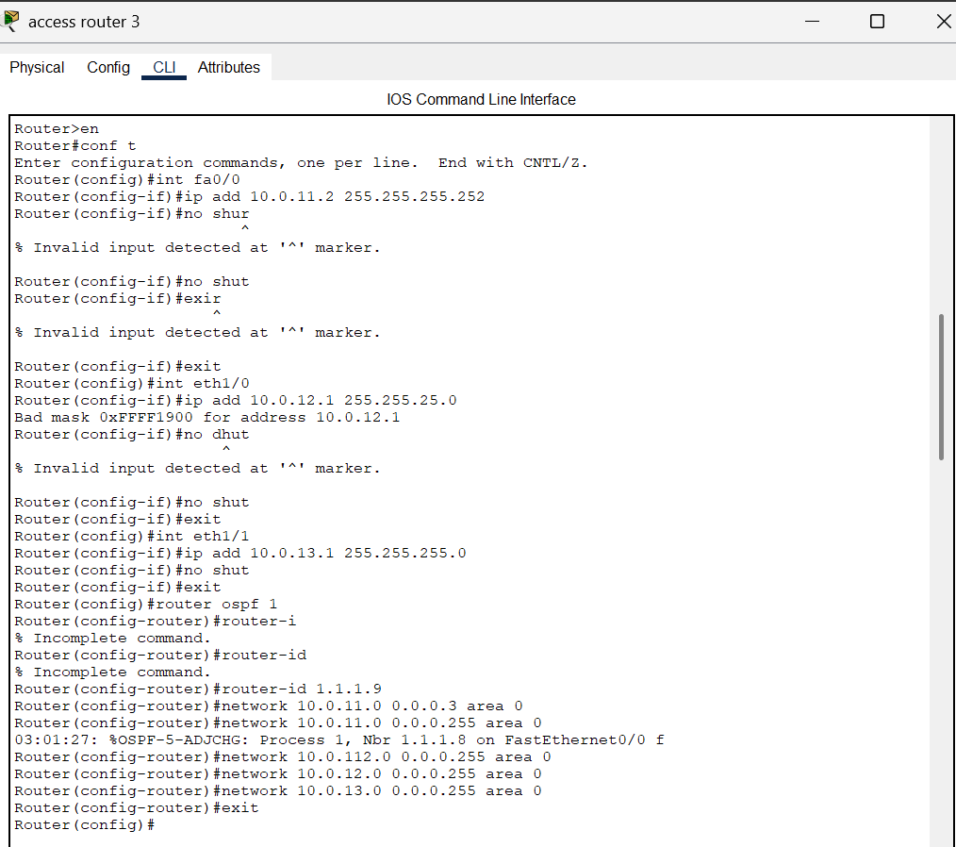

**4.15. PC-PT PC3**

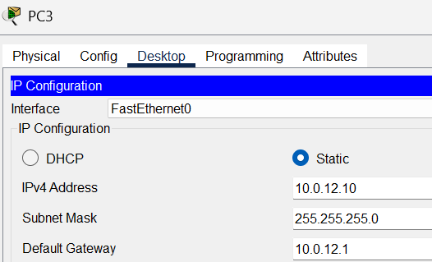

**4.16. PC-PT PC4**

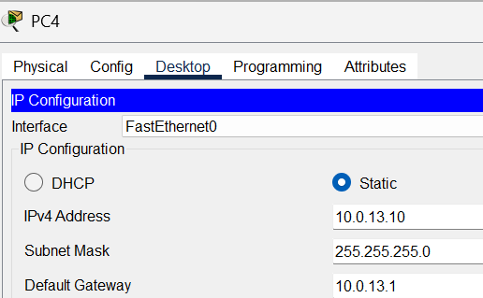

**4.17. dist router 4 (2620XM)**

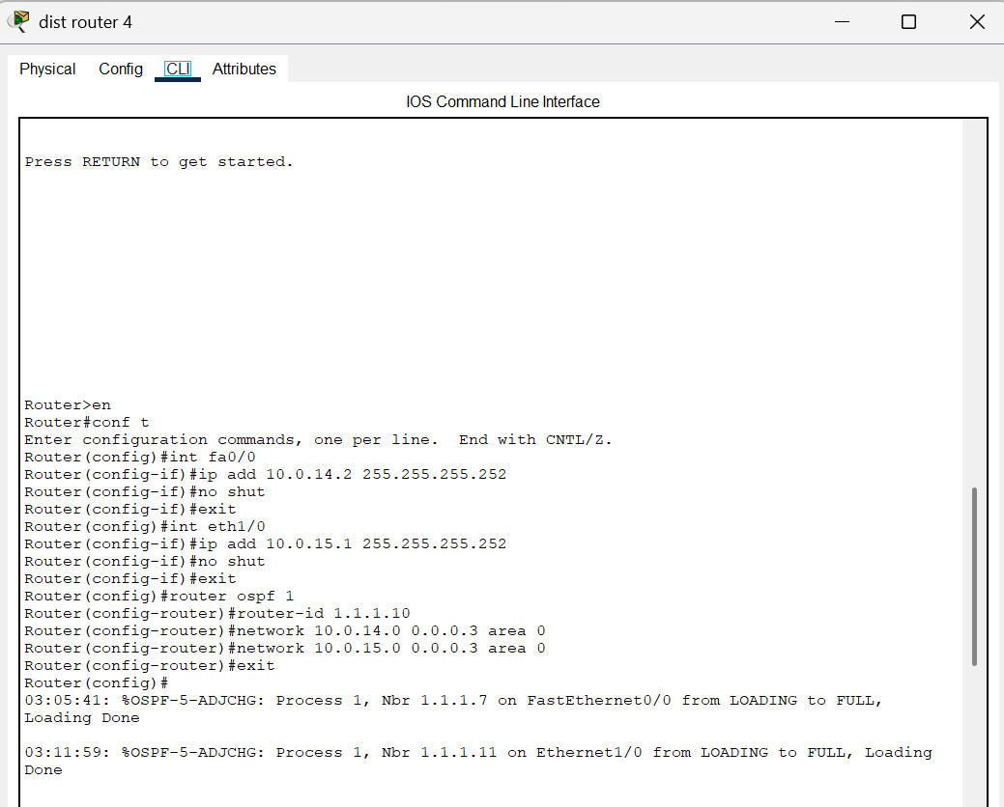

**4.18. access router 4 (2620XM)**

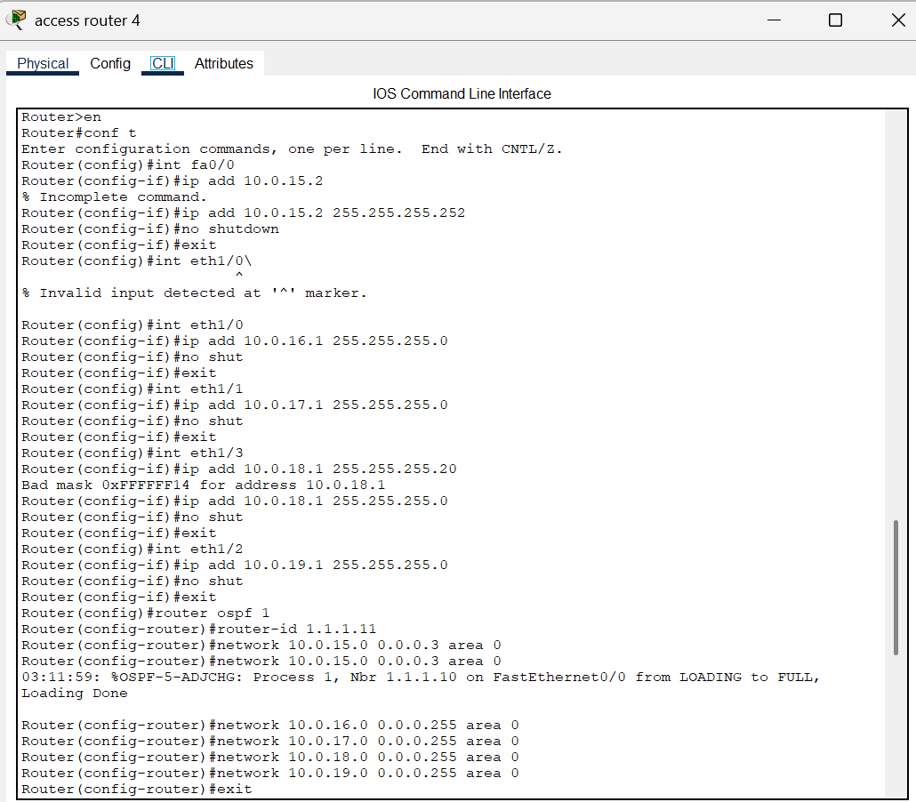

**4.19. PC-PT PC5**

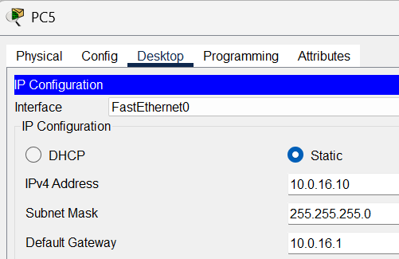

**4.20. PC-PT PC6**

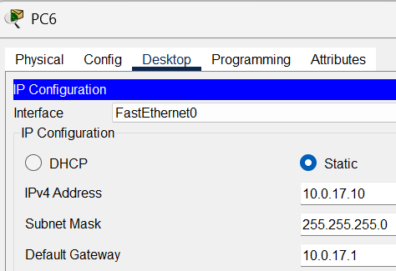

**4.21. PC-PT PC7**

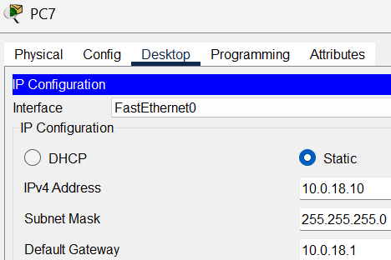

**4.22. PC-PT PC8**

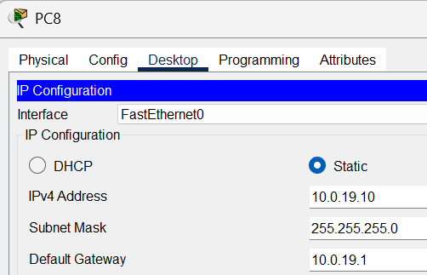

# Ping results

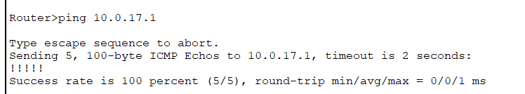

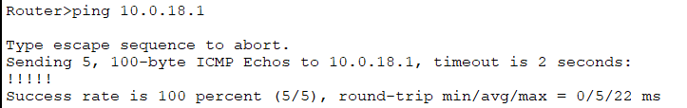

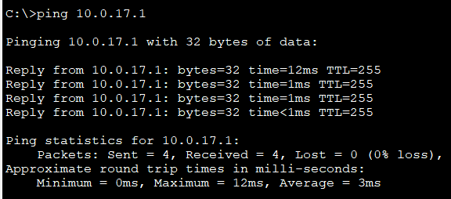

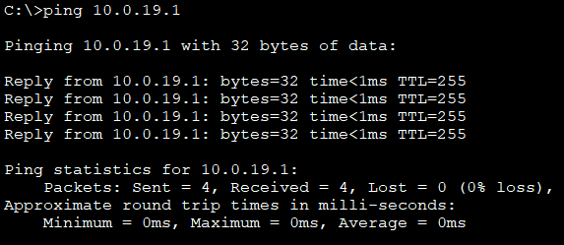

**6. Conclusion**

This project demonstrates the successful design and implementation of a complex network topology using Cisco Packet Tracer. By carefully planning the IP addressing scheme with a mix of /30 and /24 subnets, configuring OSPF as the dynamic routing protocol, and sysomrstematically troubleshooting common network issues, full connectivity has been achieved across all segments and devices. The project highlights the importance of precise configuration, understanding OSPF protocol behavior, and systematic troubleshooting for effective network management.